**Visualizations**

**Activity 1.1: Countries per Region**

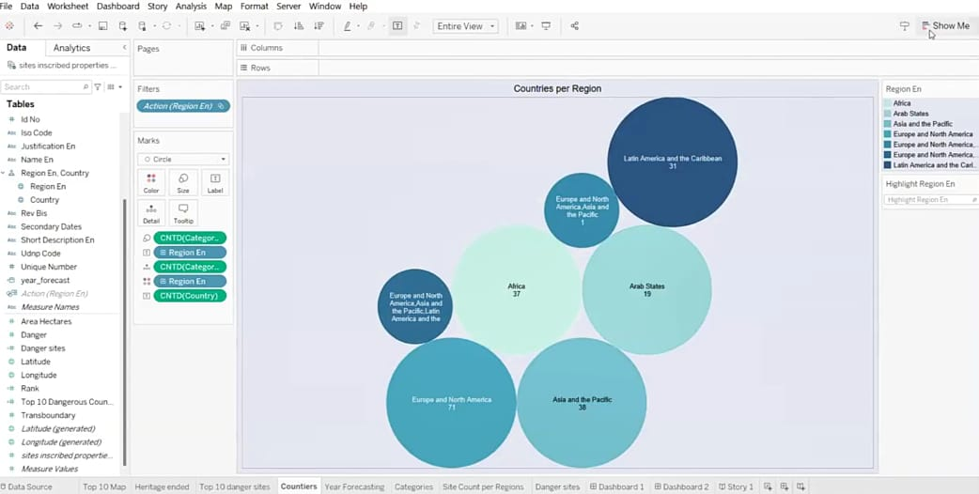

**Activity 1.2: Top 10 regions by area**

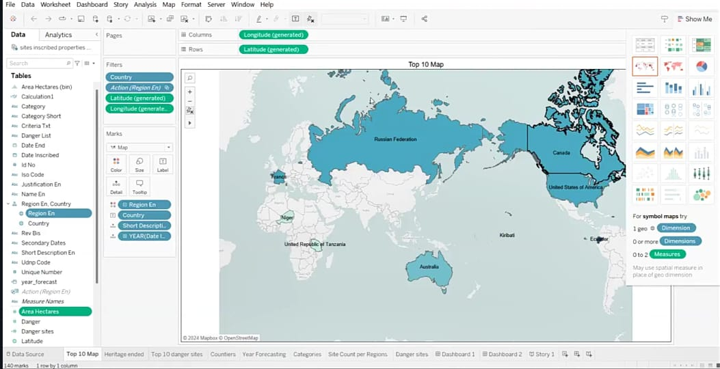

**Activity 1.3: Regions by Heritage ended**

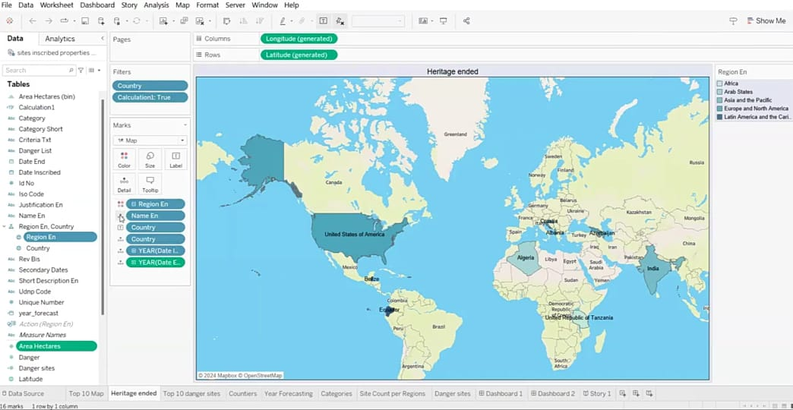

**Activity 1.4 : Top 10 Danger Sites prone to Extinction**

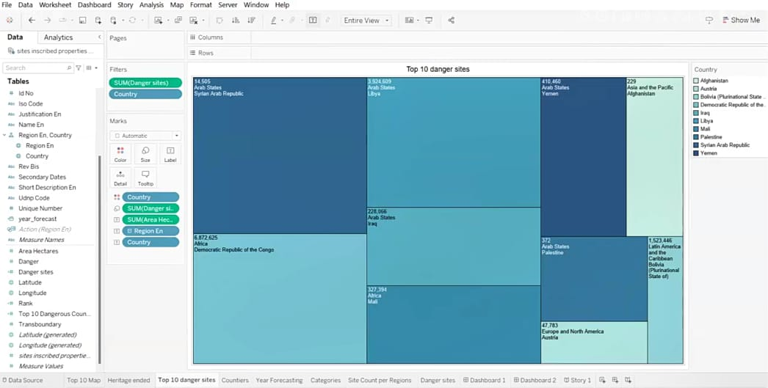

**Activity 1.5 : Year Forecasting of Heritages**

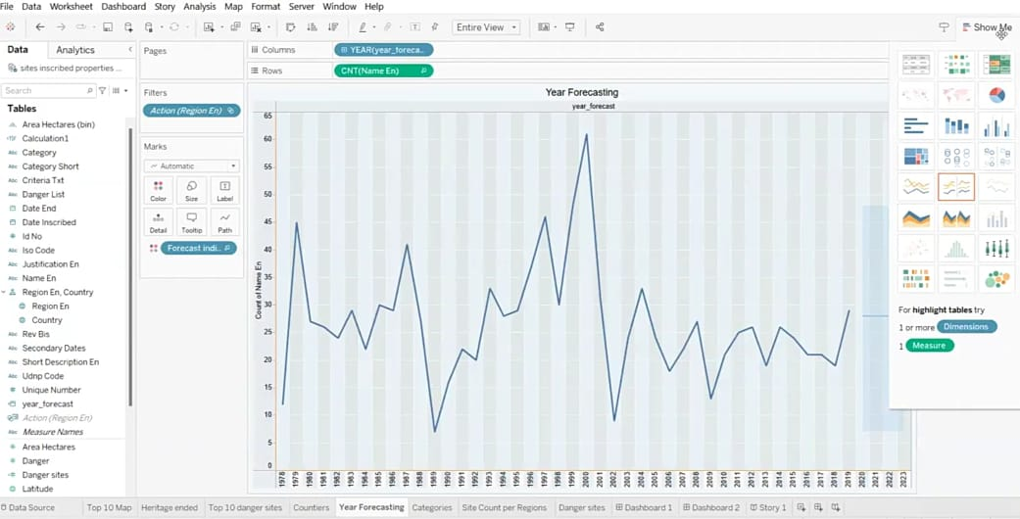

**Activity 1.6 : Categories by sites count**

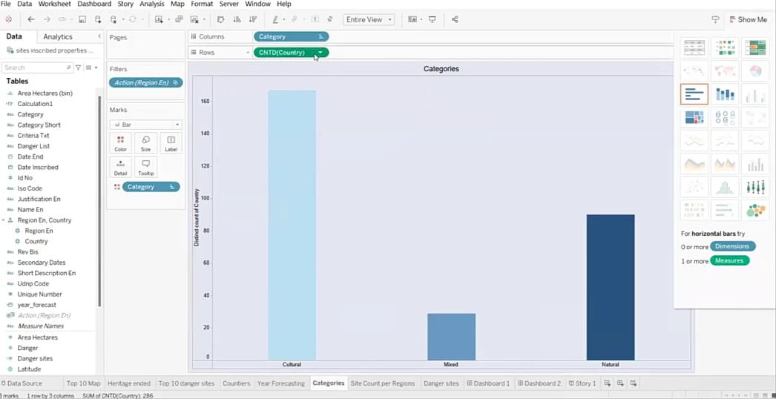

**Activity 1.7 : Site Count per Region**

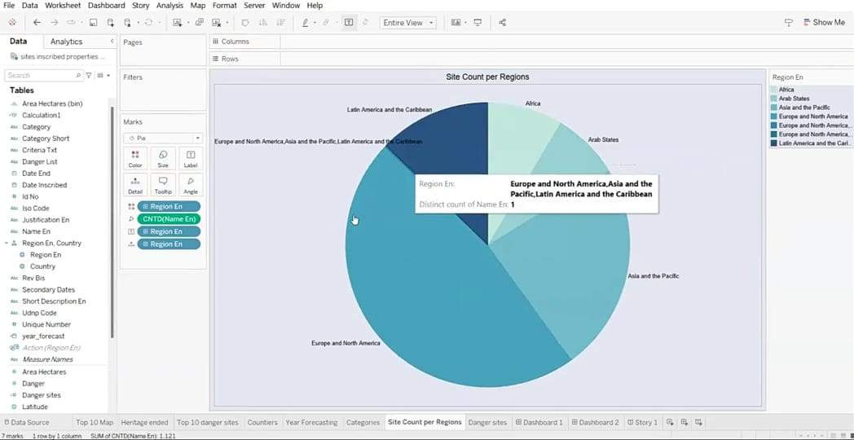

**Activity 1.8 : Analysis of Danger sites and Area of heritages**

